**Step 1: Copy the provided csv files in a directory named AirlinesOntimeAnalysis**

hdfs dfs -copyFromLocal airports.csv /user/$USER/AirlinesOntimeAnalysis

hdfs dfs -copyFromLocal carriers.csv /user/$USER/AirlinesOntimeAnalysis

hdfs dfs -copyFromLocal drivers.csv /user/$USER/AirlinesOntimeAnalysis

hdfs dfs -copyFromLocal 2003.csv /user/$USER/AirlinesOntimeAnalysis

hdfs dfs -copyFromLocal 2004.csv /user/$USER/AirlinesOntimeAnalysis

hdfs dfs -copyFromLocal 2004.csv /user/$USER/AirlinesOntimeAnalysis

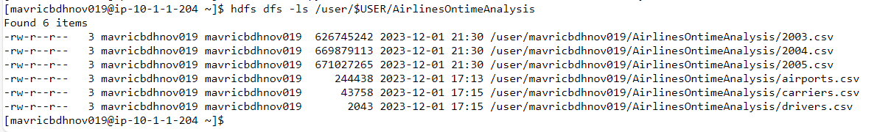

**Step 3: Create the directories in hdfs where your data will reside**

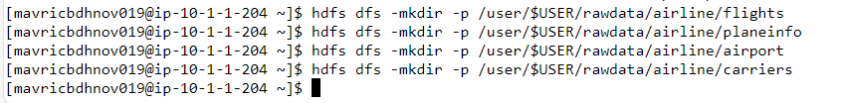

**Step 4: copy the respective files to the above created hdfs structure**

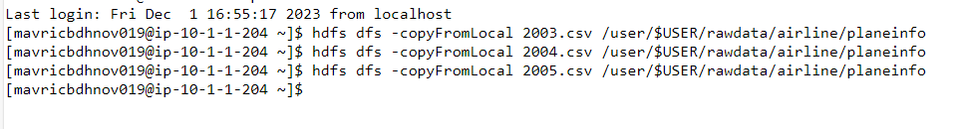

**Create all the tables in a different database in Hive(airline_db)**

**Create tables for flights , plane_info, carriers and airports in the staging area.**

CREATE EXTERNAL TABLE Airports_stg2 (

IATA STRING,

Name STRING,

City STRING,

State STRING,

Country STRING,

Lat DECIMAL(9, 6),

Long DECIMAL(9, 6)

)

ROW FORMAT DELIMITED

FIELDS TERMINATED BY ','

STORED AS TEXTFILE

LOCATION '/user/$USER/rawdata/airline/airport'

tblproperties(

"skip.header.line.count"="1"

);

Getting permission issue while creating the table.



CREATE EXTERNAL TABLE Carrier_stg2 (

Code STRING,

Description STRING

)

ROW FORMAT DELIMITED

FIELDS TERMINATED BY ','

STORED AS TEXTFILE

LOCATION 'user/$USER/rawdata/airline/carriers'

tblproperties(

"skip.header.line.count"="1"

);

CREATE EXTERNAL TABLE PlaneInfo_stg2 (

tailNum STRING,

type STRING,

manufacturer STRING,

issue_date STRING,

model STRING,

status STRING,

aircraft_type STRING

)

ROW FORMAT DELIMITED

FIELDS TERMINATED BY ','

STORED AS TEXTFILE

LOCATION '/user/$USER/rawdata/airline/planeinfo'

tblproperties(

"skip.header.line.count"="1"

);

CREATE EXTERNAL TABLE Flights_stg2 (

Year INT,

Month INT,

DayofMonth INT,

DayOfWeek INT,

DepTime INT,

CRSDepTime INT,

ArrTime INT,

CRSArrTime INT,

UniqueCarrier STRING,

FlightNum STRING,

TailNum STRING,

ActualElapsedTime INT,

CRSElapsedTime INT,

AirTime INT,

ArrDelay INT,

DepDelay INT,

Origin STRING,

Dest STRING,

Distance INT,

TaxiIn STRING,

TaxiOut STRING,

Cancelled STRING,

CancellationCode STRING,

Diverted STRING,

CarrierDelay INT,

WeatherDelay INT,

NASDelay INT,

SecurityDelay INT,

LateAircraftDelay INT

)

ROW FORMAT DELIMITED

FIELDS TERMINATED BY ','

STORED AS TEXTFILE

LOCATION '/user/$USER/rawdata/airline/flights'

tblproperties(

"skip.header.line.count"="1"

);

**Check if the tables have data.**

LOAD DATA LOCAL INPATH 'AirlinesOntimeAnalysis/airports.csv' OVERWRITE INTO TABLE Airports_stg2;

LOAD DATA LOCAL INPATH 'AirlinesOntimeAnalysis/carriers.csv' OVERWRITE INTO TABLE Carrier_stg2;

LOAD DATA LOCAL INPATH 'AirlinesOntimeAnalysis/plane-data.csv' OVERWRITE INTO TABLE PlaneInfo_stg2;

LOAD DATA LOCAL INPATH 'AirlinesOntimeAnalysis/2003.csv' OVERWRITE INTO TABLE Flights_stg2;

LOAD DATA LOCAL INPATH 'AirlinesOntimeAnalysis/2004.csv' OVERWRITE INTO TABLE Flights_stg2;

LOAD DATA LOCAL INPATH 'AirlinesOntimeAnalysis/2005.csv' OVERWRITE INTO TABLE Flights_stg2;